4.1 Related Rates

Motivation:
Suppose a conical tank is draining water slowly over time.
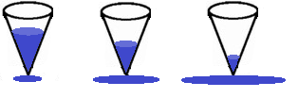

At each instant in time the volume of the water in the tank would be given by the equation , where r is the radius of the circular water base and h is the height of the water in the tank.

The volume of the water in the tank (V) would be changing over time (t).
If we were interested in finding the rate of change of the volume we could differentiate both sides of the equation above with respect to t.

So to find the value of at a specific point in time we need the values of at that specific time.

NOTE: The type of problem described above is called a related rates problem.

Steps to follow:
- Set up an equation(s) that relates the needed variables in the scenario. (Like the volume equation in the motivation. This will often require us to make use of some geometrical notion.) Drawing a picture can also be helpful before setting up an equation(s).

- Take the derivative of the equation(s) with respect to the correct variable.

- Evaluate the derivative at the specific moment in time given.

Note: A common error is for students to go to step 3 too early. Remember that you need to be working with variables when you take a derivative. It IS possible to plug in for variables that DO NOT change in step 1 (i.e. values that are fixed in the context of the problem).
Example 1: Assume that oil has spilled from a ruptured tanker and spreads in a circular pattern whose radius is increasing at a constant rate of . How fast is the area of the spill increasing at the moment in time when the radius of the spill is 60 ft?
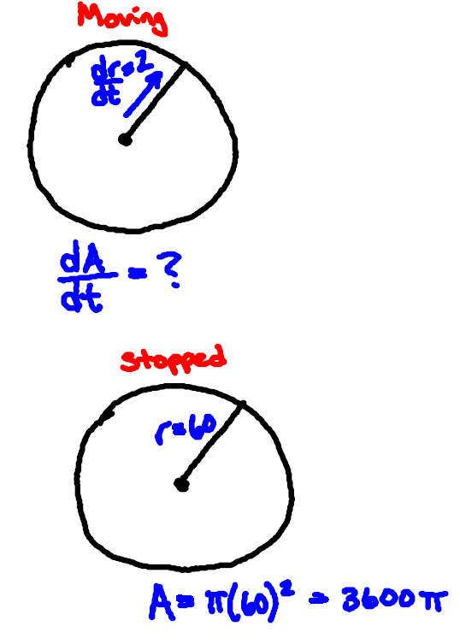
Step 1: The area of circle is:

Step 2: Note that:

Step 3: We want to evaluate the derivative when and it is given that . So

Therefore we have found that the area of the spill is increasing at a rate of.

Example 2: Car A is traveling west at and car B is traveling north at . Both are headed for the intersection of the two roads. At what rate are the cars approaching each other when car A is 0.3mi and car B is 0.4mi from the intersection?
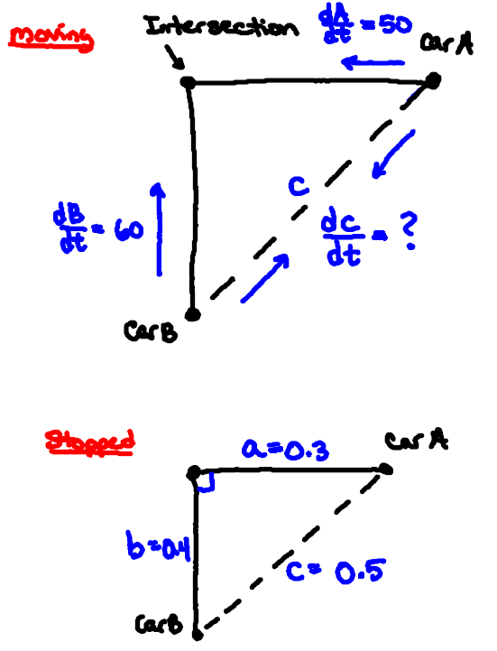
Step 1: By the Pythagorean Theorem we know that:

Step 2: Note that:

Step 3: It is given that and we want to evaluate the derivative when (we can use the Pythagorean Theorem to solve for c at this moment). So,

The rate at which the cars are approaching each other is .
Example 3: An airplane is flying in a straight direction and at a constant height of 5 kilometers. Let the angle of elevation of the airplane from a fixed point of observation be called . The speed of the airplane is . What is the rate of change of angle when it is ?

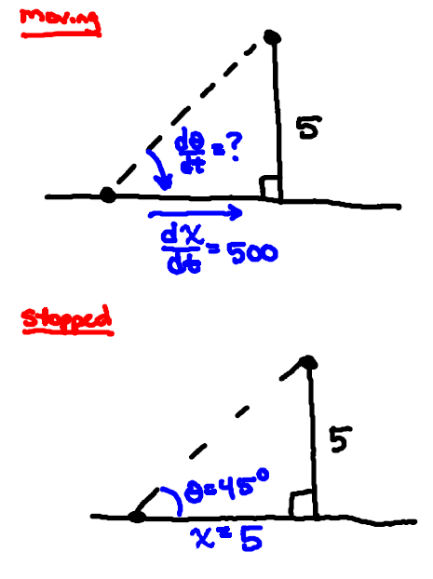
Step 1: We know from right triangle trigonometry that:

Step 2: We note that:

Step 3: It is given that and we want to evaluate the derivative when (at this point we can solve to find ). So,

The rate of change of the angle is .

Note: Our answer is in radians per hour since our derivative formulas for the trig functions are not correct unless we work in radians.

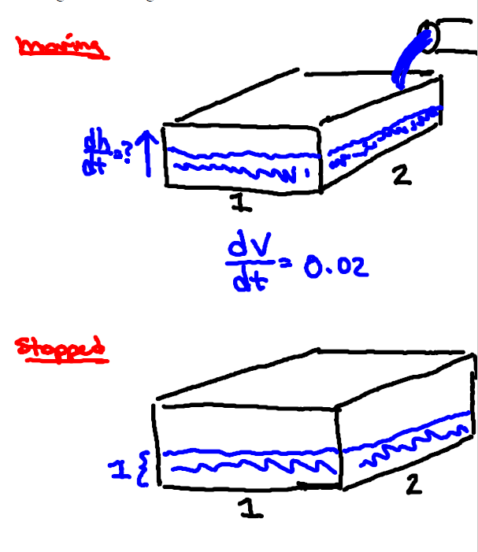
Example 4: A rectangular water tank is being filled at the constant rate of . The base of the tank has dimensions . What is the rate of change of the height of water in the tank when the height of the water is ?

Step 1: From geometry we know that:

Step 2: We note that:

Step 3: We want to evaluate our derivative when . So,

The rate of change of the height of the water in the tank is .

Example 5:
Suppose that liquid is draining from a conical tank with a radius of 4cm and a height of 16cm. Suppose that the liquid drains at a constant rate of . At what rate is the depth of the liquid changing at the instant when the liquid in the cone is 8cm deep?

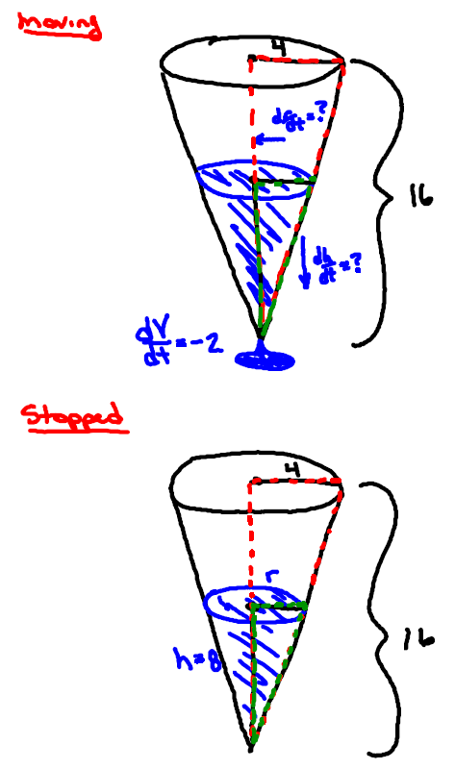
Step 1: We are interested in looking at the cone of liquid in the following diagrams. Therefore, let V be the volume of the liquid in the tank, let h be the height or liquid in the tank, and let r be the radius of the circular base of liquid in the tank. From geometry we know that:
We have too many variables!

We want to find but the problem gives us no direct information about . So, we have to find some way to eliminate the variable of r.

By similar triangles we obtain:

So we express the volume of water in the tank as:

Step 2: We note that:

Step 3: We are given that and want to evaluate the derivative at the time when . So,

The rate of change of the height of the water in the tank is .

